2nd Year Studio ARCH 2016, Spring 2022
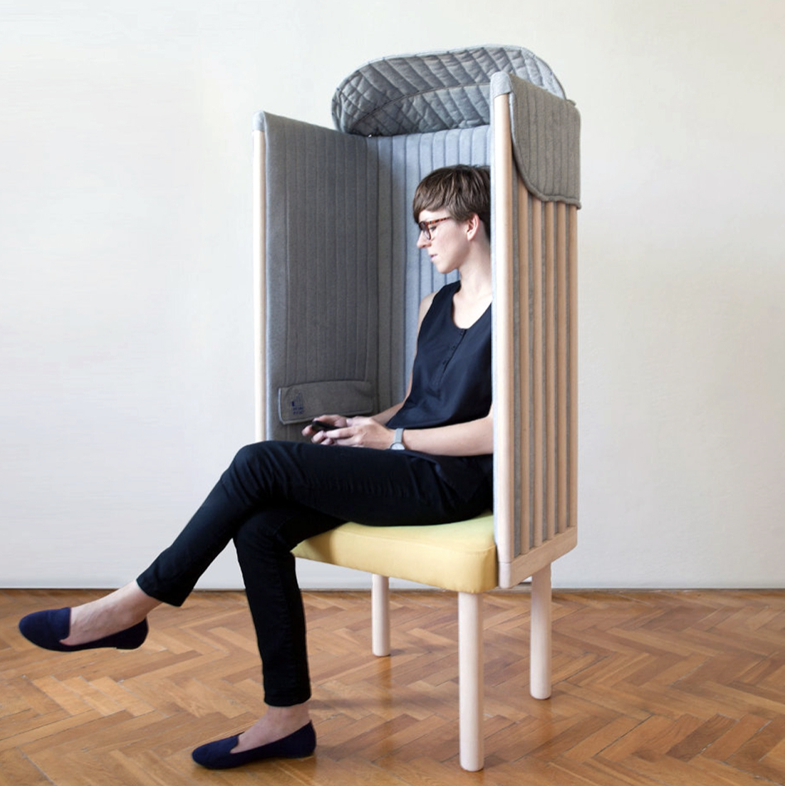

Studio Professor

Henri T. de HAHN

Studio: Cowgill Hall 3rd Floor
MWF 1:25 – 5:15pm
Seminars: TBD
Office hours: MWF 11:00 – 12:00 or by appointment
Contact: Office: 540-231-2680
Email: hdehahn@vt.edu

Chair
https://inhabitat.com/take-a-break-from-the-wired-world-with-this-awesome-signal-blocking-offline-chair/

Charette 2: 72-hour furniture design

The success of your kitchen design has led Agnes to entrust you with assisting her with suggestions for furniture and the layout for both the master bedroom and a room of your choice (living room, dining room or library). She insists that her husband Roger will have no say in this endeavor as she claims that he can never make a final decision. While there is no budget, remember that Agnes is Swiss, thus is frugal and may need to be convinced if you have some grand ideas regarding specific accent furniture pieces that are essential (meaning that YOU cannot live without), but whose price is over the top. Up to Agnes to convince Roger to pay for your lack of frugality!

Assignment
The time spent on this exercise is brief and should be dedicated to responding to the following design issues that are both architectural and within the domain of interior design:

- Define Agnes’ personality and imagine her taste. That will allow you to interpret her needs. These might range from her desire for an uncluttered and understated space or a pretentious and ostentatious living environment for her and her family. Don’t forget, as you have been invited several times to their summer home—that you designed for Agnes, Roger and their two sons—you might have a clue from the way they have furnished that home.
- Provide an aesthetically coherent and pleasing scheme in terms of the overall “look” and “atmosphere” that you wish to create for the two spaces. This should be accomplished primarily through your judicious choice of furniture.
- Particular emphasis needs to be on the functionality of each of the pieces of furniture, their aesthetic, shape, color, fabric and texture in order to create a unifying space with appropriate accent pieces based on furniture groupings, area rugs and lighting.
- In the layout of each room, think of functionality and how the space will be used during particular times throughout the day.

Schedule and presentation requirements
- Provide 3-4 well written paragraphs on Agnes’ personality and how that will influence the design
- You are to research all furniture, understand the manufactured specifications and dimensions
- Digitally copy each of your choices and compose them on 1 or 2 vertical 24 x 36 panels, which will constitute the final printed color presentation. We will visit a class in Interior Design to get acquainted with their mode of presentation regarding furniture choices.

NOTE: This charette is to be conducted concurrently with the progress of your design project, and may affect certain spatial conditions that you had previously established.

