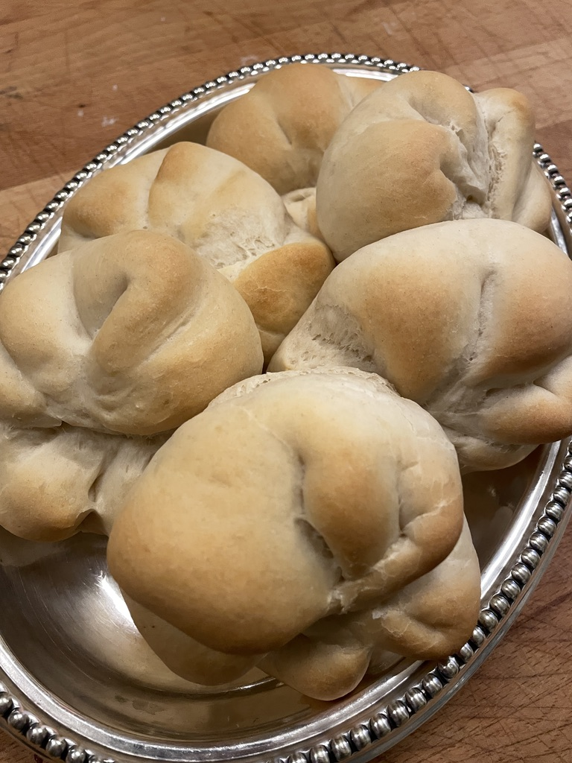
Austrian Semmel
Rooteddeephomc.om

Pre-dough
1 cup all-purpose flour (120 grams)
1 and 1/2 tsp salt (8 grams)
1 tsp sugar (5 grams)
1 cup lukewarm water (210 grams)
2 and 1/4 tsp dry active yeast (10 grams) or 1 standard packet

Semmel Dough
2 tbsp unsalted softened butter (30 grams)
1/4 cup milk (50 grams)
2 and 1/4 cups all-purpose flour (305 grams)

Photograph Henri T. de Hahn

- In a large mixing bowl, combine 1 cup all-purpose flour, 1 and 1/2 tsp salt, 1 tsp sugar, 1 cup lukewarm water, and 2 and 1/4 tsp dry active yeast. Whisk the pre-dough thoroughly, then cover with a towel and rest for 10 minutes or until the yeast is activated and bubbly.
- Add the 2 tbsp unsalted softened butter and whisk until incorporated. Then add 1/4 cup milk and 2 and 1/4 cups all-purpose flour, kneading together until smooth, about 6-8 minutes.
- Grease a large bowl and place the dough in it. Cover and rise for approximately 30-45 minutes or until doubled in size.
- Divide the dough into roughly 8 equal-sized pieces and shape each piece into a smooth round ball. Cover the dough balls with a towel and allow them to rest for 15 minutes.
- Create the star shape on each roll by first flattening the dough into a disc shape about the size of your palm. Then, place your thumb in the center of the disc and fold down the top half of the dough over your thumb. Use the edge of your palm to indent the dough, then fold over into the center and press the dough to secure.
- Continue this folding pattern four to five times, ending the last fold by tucking it into the thumb hole. (See the video for folding instructions or simply use a Kaiser stamp for easy and perfect pastry patterns.)
- Place each shaped roll on a parchment-lined baking sheet, cover, and rise for another 30 minutes. Preheat the oven to 450 degrees F.
- Use a spray bottle filled with water to spritz each roll immediately before transferring the baking sheet to the oven. Reduce the oven to 400 degrees F and bake rolls for 18-20 or until golden brown. Allow the baked rolls to cool on the baking sheet for 5 minutes before transferring them to a wire rack to cool.

NOTES
- Shaping rolls into the traditional star pattern can be tricky. An easy way to do this is by using a Kaiser stamp. This pastry tool makes pressing a perfect star into each roll a breeze.
- Instant yeast can also be used in place of active dry yeast. If you opt for instant yeast, you can skip the pre-dough activation step and simply combine all the ingredients, mixing until a well-combined and smooth dough forms.
- A stand-mixer makes the recipe even easier, though you do not need one!
- Be sure to spray the rolls with a spritz of water immediately before popping them into the oven to ensure a nice crusty exterior. You can also place an oven-safe dish filled with water on the bottom rack for extra steam during the baking time.

