MEMORANDUM 1

To: ARCH2015-F2021
From: Henri T. de Hahn
Date: 07.27.2021
Ref: Required and suggested design studio materials

Dear Students,

I would like to start our academic design studio year with good habits, and one of them is to have available for your design studio usage a number of drafting items that are necessary for this upcoming year. As you have concluded your first-year, many of them might already be in your possessions However, I do understand that faculty favor certain items over others, thus I thought to give you a head start on what I will need you to have.

The below pictures accompanied by numbers (green is required, and orange suggestive) were pulled from many of those that I bought when I was a student myself. For example, the lead dates back to the mid 80’s and the parallel bar was my prized purchase when I attended the I.A.U.S in New York City in 1983. In Europe we only had T squares and to own a parallel bar was an incredible treat. I still cherish it when drafting (see the bathroom plan on the drafting board under all of the featured items…).

All of the required items will need to be at your desk no later than the second design studio session. You may purchase them near your home, on Amazon, Michael’s or near campus at the New River Art & Fiber store located at 101 South Main Street.
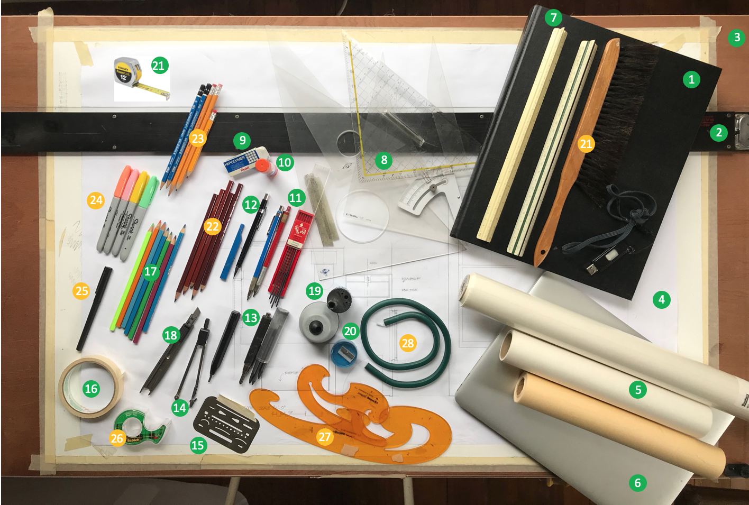

List of required items (in green)

- A black unlined notebook (no spirals) size 11”x14”. THIS IS A MUST. You may wish to own other notebooks which are welcome but studio work will work with the larger sketch book size. Ideas need to be BIG, thus a large notebook; I will show you mine…
More than ever, especially as you are starting to learn the fundamentals of architecture, to own a notebook is necessary as I will ask you to do most of your initial ideation sketches in your notebooks. It keeps track of your ideas and progress and I hope to include some of my sketches as well that are offered during design crits. You will see that I will continuously sketch our discussions with you.
- The features image shows a parallel bar of 48 inches. It has been my companion for over 30 years but I will be honest that I started with a simple inexpensive wooden T-square, thus it is up to you to make an assessment on how much you wish to spend on this item. Both items work fine to the exception that for the T-square, you will need an edge to use it appropriately (see under 3).
- This is always the catch 22 question. Should I purchase a typical drafting board? Let me be honest and say no. During my studies, and still now, I have a hollow core door/1/2”/3/4” plywood sheet on which I tape a Bristol paper large enough to hold drafting paper or sketch paper of the size 24 x 36 inches, the size of many drawings you will be producing. I did not have much money when I was a student and came to love the hard surface where I felt I could control better the line weight of my pencils.
Thus, I invite you to simply get some large paper (I have some available for you) and tape is as in the image onto the desk provided by A+D or purchase a door and set in on your desk. Of course, you could also purchase plywood in lieu of the door and set in on your desk. Either work well and I do not encourage the purchase of a drafting board. They are expensive for no need.
Finally, I know that some students favor a plastic sheet on their drafting surface. I find it unnecessary but you need to feel comfortable in how and what you wish to draw with.
In resume, you will all need to have purchased by the second day of studio some type of drafting surface. If you have any questions, please do not hesitate to reach out to me.
- As stated under 3, simply set a large white piece of paper on your desk and use it as a background to set your drafting or sketch paper that will be used to sketch your ideas. If background paper gets used, is torn or you have equally drawn on it, just replace it at your convenience.
- As you/we will draw and sketch a lot in your notebook, I require that you have at least two rolls (2) of sketch paper; one 12 inches and one 18 inches. You may wish to choose white or yellow. It’s up to you. When I arrived in America, the yellow tracing paper, also commonly called flimsy, was so new to me because this item did not exist at that time in Europe. I learned that the yellow was used for initial ideation such as sketching, diagraming and conceptualizing, while the white color was used for more permanent drawings prior to moving to vellum (a thicker more robust transparent paper) which was used for final inking of the drawings.
While I understand that some faculty in first year required that students had to do all their drawings on paper. We will discuss this requirement which will not exist in my studio. The medium is up to you when I do not require specific deliverables.
- I suspect that you have a computer with all the appropriate software. I do not require any special computer, nor any specific drawing program. We will draw digitally during the spring semester after a thorough mastering of most drawing skills during the Fall semester.
- Critical to being an architect is to work at scale, thus you are required to own an ARCHITECTURAL scale. The second scale next to the one under number 7 is an ENGINEEERING scale and will not be necessary. The difference is explained in this blog.
- Also, to be able to draft, you will need at least two different triangles: one thirty/sixty degree and the other one is a 45 degree one. Having both of them is critical and I will show you the tricks that I learned to assist in quick and precise drafting. The yellow 45-degree triangle (swiss and/or German made) is one that I prize and many of my past students could no live without one. It has lines and degrees on it, thus making is a miracle tool when drawing parallel or perpendicular lines or event lines on a certain angle, and this is a fraction of a second. If you are interested in owing your own, you may find under at amazon: https://www.amazon.com/723250100-Set-Square-Plexiglass-Clear-Backing/dp/B0046IYYP4/ref=sr_1_10?dchild=1&keywords=rotring+triangle&qid=1597677246&sr=8-10. The original brand ROTRING is so much more expenses that the featured one is perfect.
NOTE: many students favor metal triangles. Up to you, but I find the inexpensive acrylic ones to do just very well. The metal ones seem very architectural but not worth the extra money, but please make the right choice for yourself based on all the good reasons… Also, when they are dropped on the floor by accident, they tend to chip easily compared to the more flexible acrylic ones.
- A little glue stick that will always come in handy, especially during the rapid sketch modeling exercises.
- An eraser as you will need to adjust and change constantly your drawings.
- It is important to have a Technical Lead Holder and I encourage you to at least have two (2) to hold either the 2mm 2H, HB, or F lead. They are easily available and the generic ones are inexpensive. Please do not forget to equally purchase the leads for these lead holders.
- When drafting more precisely, I favor using a mechanical pencil as you do not need to sharpen the lead and it, if used appropriately, will give you a very nice and constant line weight. I have several sizes but the one I recommend is the one with 0.5 mm lead (metric size). I also have an 0.7 but I tend to always return to the generic 0.5mm.
Also, please purchase lead for this mechanical pencil and I recommend that you always have the three basic leads: 2H, HB and F. You can draw an entire plan with only those three lead weights. Typically, when purchasing a new mechanical lead holder, it comes automatically with HB lead. Walmart has the least expensive ones.
- The day I arrived with my stumpy, students were envious of how this tool gave them the opportunity to sketch freely and instantaneously. I have purchased so many as I lose them or give them to students. This is one of the best lead holders you will need when sketching, diagramming or conceptualizing because you cannot be precise in your line (I will explain why this is an asset). There are several brands to choose from, but the real the differences are that the lead is graphite with a 5.6 mm lead size. PLEASE buy one and get the HB lead. For your information, please find a link to one that I found on Amazon. Do your research and you will find the one that meets your personality: https://www.amazon.com/Automatic-Mechanical-Graphite-Sharpener-Sketching/dp/B07CMQ2Z7C/ref=sr_1_3?dchild=1&keywords=lead+holder+thick&qid=1597678081&sr=8-3 or under lead holders thick 5.6 mm on Amazon: https://www.amazon.com/s?k=lead+holders+thick+5.6+mm&ref=nb_sb_noss
- An inexpensive compass will be perfect for what we need to do. I will show you in studio a set that I purchase some years ago for my birthday and to celebrate when I had my first administrative job at Cal Poly. Did I need it, NO, but it was so beautiful…?
- An old fashion drafting tool, which always comes in very handy. The eraser shield enables you to erase only specific areas without making a mess of your entire drawing. The tape I set on the top of the metal eraser shield is to allow me to pick it up as it is very thin and otherwise difficult to handled. I heard that students used to glue penny on one side. HMMM.
- Masking tape is a must, so get one immediately. No need to get the fancy little dots…
- Colors pencils are inexpensive and a must to highlight your ideas. Get the minimum set of Crayola (generic brand at Walmart). Last spring, I splurged on a Walmart set of 100 color pencil. Love all the different colors. Makes me think back when I was a kid.
- For model building, the generic snap-off 9mm blade (featured in the image) or utility knife, and blades is a must. We will learn how to created sketch models (see three blogs) and study models. You may wish to get an X-Acto knife but I personally find that they do not offer much precision when cutting, also students typically cut their fingers with the X-Acto blades.
- There are several lead sharpeners which are a must. The gray one is the one that I had as a student and is Swiss made. It is so comfortable but the adjacent one to its right is just perfect.
- Of course, please have a generic pencil sharpener.
- Finally, it seems evident but having a tape measure is so important. While architecture is about setting your ideas into space, dimensioning is critical to lend beauty and correct proportioning to your spaces.

List of suggested items (in orange)

The below items ease and complement your drawing arsenal. Yet there is no need to purchase any of them, but just wanted to let you know what I used as a student.

- It’s always nice to have a little brush to get rid of all the annoying eraser leftovers.
- A set of graphite artist pencils to draw is most welcome.
- I typically love the various color markers when I teach, for as a designer I always find having colors and different width of pencils and markers belong to the mood in which you are designing and thinking. A fine 0.5mm is to draft and not to sketch, a thick lead as in number 13 is never to draft and always to sketch loosely… Add color to your way of expressing yourself and everything will show hierarchy and enables you to better clarify and understand what you drew, and in particular in conveying your ideas during desk crits.
- Generic pens to write down in your notebook or sign your first contract is good to have.
- Scotch tape always comes in handy.
- These tools assist you when you need to draw complex curves that the compass cannot do. These were the only tools available at the time of my studies. Computers have now replaced them, but when I draft I occasionally refer back to them to draw or make models. As you can see they are beaten up utensils!
- At last, we called it a snake and this tool enable—with some dexterity—to create a wild and crazy curve and draw it appropriate. Not useful for you but just memory lane for me.

Final notes.
- I have and you should always trust my/your fellow colleagues, but at times a student might inadvertently borrow a tool or item with the firm intention of returning it, sometimes it never comes back. Thus, I invite you to mark your name on each of your items. For most items, I simply used the needle of my compass and scratched my name or initials on most items. For the tracing paper and masking tape, I would simply write my name inside the roll, thus it was visible yet discreet.
- Please purchase all required items for the second design studio day. No excuses.
- The examples shown in the above image are generic utensils and while each one has a brand, I tend to like generic brands that work well. It is the author’s genius that will make the difference in you project, but having good and solid drafting tools is a must. However, looking at web pages, I am reminded how many utensils have been elevated to works of art. Perhaps you might, after working with a generic item, wish to have one given to you as a Birthday gift. Some are simply spectacular and surely show off that you are an architect of good taste.

